Name of subject and class

Assessment 4

Analysis of the Airbus A360 Project

Student Name and ID number

Lecturer:

**Introduction**

The Airbus A380 initiative, which was started with the hopes of shooting stars, was designed to change aviation's way of thinking forever by developing the world's largest passenger airliner. Airbus A380 is an aircraft with advanced technology that completed impossible tasks and made history; it was the first aircraft with this capacity. Yet, its journey had several complex challenges, which made it commercially unsuccessful analysis is carried out based on a compilation of reliable scholarly resources, including, Ádámọ-Keji's 2021 in-depth research on the procurement management processes at Airbus, Dörfler & Baumanns's 2014 work on lessons from A380's extraordinary Failure, and Geng and Bhattacharyahs 2021 detailed account Moreover, the supplemented arguments by Lawrence & Ablauufia (2006) about the A380's strategic position, Nikolai's (2009) Risk management, Nelson's (2020) Concern about market response and Nikolaishvili and Chama's (2007) Contributions on the effect of the A380 on The studies which portrayed the contrast between the defining features of the A380 and the obstacles in the implementation of its innovative ideas serve as the starting point for an in-depth examination of the project - it was a sound idea, yet the technological superiority alone was not enough to pull the venture through, eventually having the market impediments and operational flaws outweigh the bright side.

**Background of the Failed Project**

The Airbus A380 program began with great expectations and was intended to change air transportation by creating a big passenger airliner. The company's efforts were highly targeted at the strategic objective of Airbus to go right to the core of the long-haul large-capacity enplane segment, expecting growth in air travel and hub connectivity in airports (Adamokẹjí, 2021). Airbus was willing to try the A380 as a solution for peak passenger flows through airports and as a way out of the slots limitation by betting on the industry's future passenger traffic pattern, hub-to-hub (Lawrence & Abaloufia, 2006). However, the position was not always so favorable as the myriad of issues with leading multi-millennium projects often overwhelmed the technological inventiveness and the extreme complexity of the logistics. Considering its extraordinary technical achievements, the designed model could never deal with its initial financial burdens or technological glitches. It also faced problems related to supplier coordination and cross-border teamwork (Dörfler & Baumann, 2014). These concerns were compounded by the fact that the market rapidly evolved to fuel-efficient, smaller aircraft capable of point-to-point routes, which differed considerably from Airbus's initial market expectations (Geng & Bhattacharya, 2021). The aircraft project's ambition, though remarkable, led to Airbus' objective set disparity with the realities of the global aviation market, setting the background for the obstacles that finally overpowered the overall benefits of the aircraft (Naikal, 2009; Nelson, 2020; Nikolaishvili & Chama, 2007).

**Scope/Objective of the Failed Project**

The Airbus A380 project, having been launched with a significant objective, targeted to reshape global aviation by introducing the biggest passenger aircraft in the world. This project objective aimed to provide the carriers with airplanes that will go beyond the usual introduction of an aircraft but will redefine long-haul travel due to elevator-like comfort, capacity, and efficiency (Ádámọ-Keji, 2021). Being broad in scope, the project involved not only designing and manufacturing but also making provision for 853 passengers on economy fares (whole class) or around 500 passengers in a typical three-class setting, which was way higher than any other plane of this nature (Lawrence & Abaloufia, 2006). The objectives were clear: to elicit the growing market interest for the long-distance and high-capacity routes and to highlight Airbus's position among the largest aircraft segment, which will be a point of competition for Boeing.

The Airbus A380 project was a market response based on an expectation that air travel would increase significantly within the following decades, especially in China and other growing countries. The major airports will soon face a bottleneck, which would mean more people flying and needing an aircraft to transport them (Nelson, 2020). This was coupled with saving fuel by increasing fuel efficiency and providing comfort to passengers, which airlines expected to focus on in terms of cost efficiency and diminishing the environmental impact (Geng & Bhattacharya, 2021). The project was financed extensively, where the development cost was estimated to be over €15 billion, which, in the latter end, could be cited as a massive financial burden for Airbus (Nikolaishvili & Chama, 2007).

On the other hand, planning and executing such mega-projects was difficult due to the organic and complex web of issues involved. The meticulous process of having production lines running across so many different countries and suppliers went pretty well. Eventually, it led to severe bottlenecks, mainly due to problems with the plane's wiring system, the complications of which were much higher than anticipated (Dörfler & Baumann, 2014). The difficulties in operation, furthermore, mainly relied on the fact that plane procurement was not sufficiently attended and a risk management framework was utterly absent. (Àdámọ́-Kéjì, 2021; Naikal, 2009).

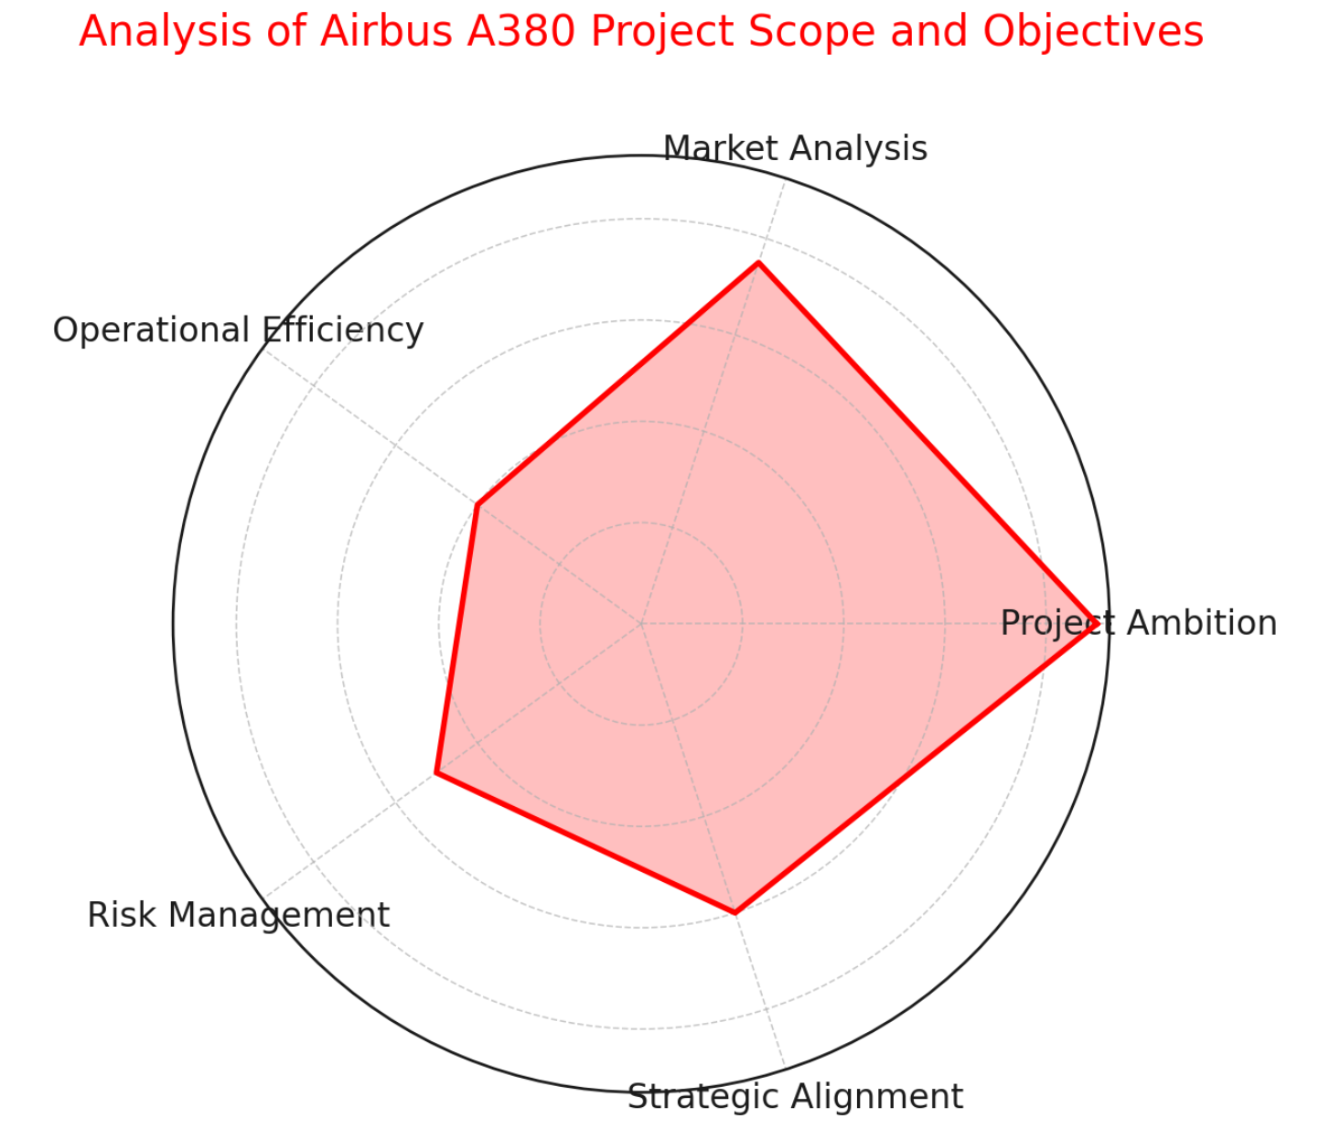

**Planning/Execution of the Failed Project**

In the Airbus A380 planning and execution case, the complexity and challenges of a large-scale, technologically advanced aerospace program are exhibited. The A380, since its inception, was imagined as a game changer in the aviation industry, not only in terms of the plane's size but also in terms of its goals to surpass state-of-the-art air travel efficiency and traveling quality. Apart from deploying a vast global industry network, the project worked towards leading the introduction of state-of-the-art technologies. This would be, as (Ádámọ-Keji, 2021; Lawrence & Abaloufia, 2006) points out, a gearing towards meeting its target.

Though the operation of the A380 program was accompanied by challenges, primarily in its supply chain maintenance and the partial integration of systems, these obstacles enabled us to get even stronger and more experienced. Despite comprehensive pilot preparation with detailed work breakdown structure (WBS) and management processes, the project manager tried to balance supply, demand, time zones, and geography. These complexities resulted in many struggles, such as miscommunications, logistical clogs, and delays, especially in the interweaving of the aircraft's advanced entertainment and navigation systems, which were technologically more detailed than those of the previously dated models (Dörfler & Baumann, 2014; Nikolaishvili & Chama, 2007).

A major blunder in the project execution phase was that they ignored that turning up production at a considerable rate might bring a lot of problems that would slow down the delivery process. As Geng & Bhattacharya (2021) note, during the construction, attempts were made to accelerate the attempts to fish rate, which generated more costs and hindered productivity. These concerns became exaggerated because the risk management plan was depicted to be very weak and complex. Despite the risk management strategies framework that had arisen, the project team was later unable to avoid subsequent and more technical and logistical problems.

The learning experience from performing such a massive project as A380 perfectly shows that flexibility is essential in project management and that effective communication and coordination mechanisms are necessary at all levels of the supply chain. Moreover, the Airbus A380 project delays manifest that the proper integration of schedules with real risk assessments is a crucial prerequisite, as demonstrated in the Redafi Research and Development Africa Initiative and Nelson (2020).

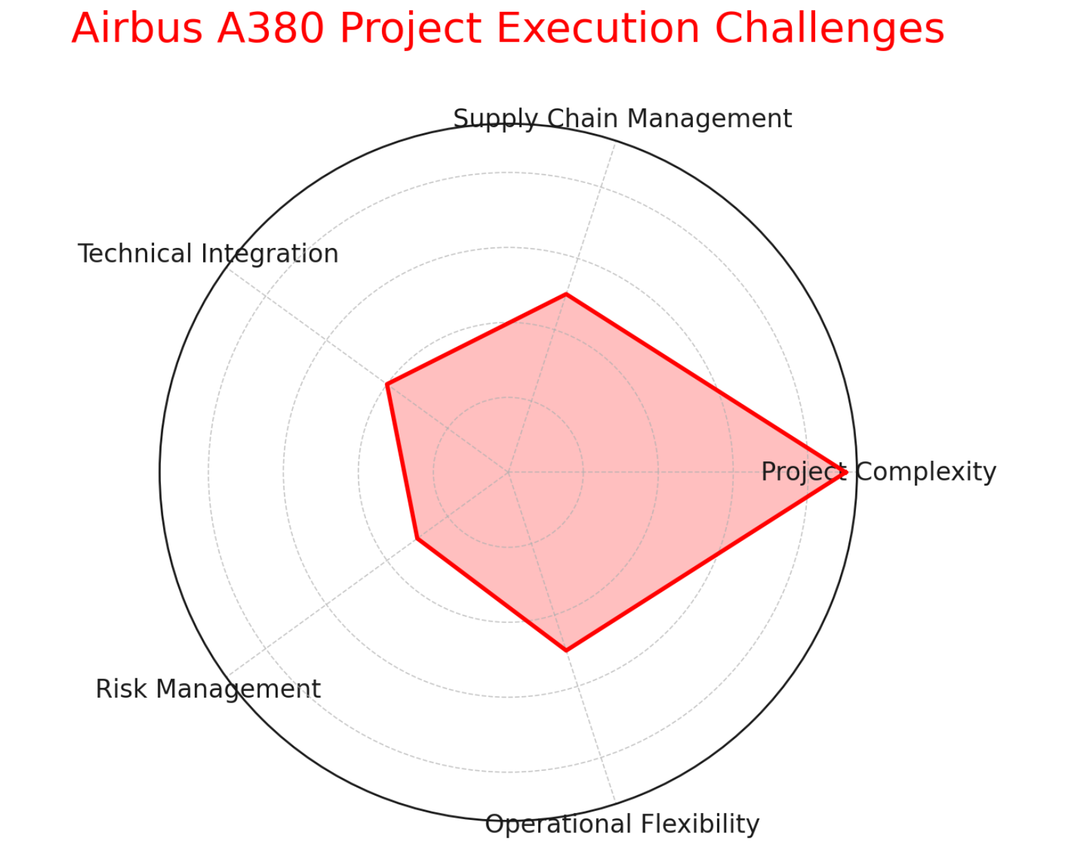

**How the Project Failed**

The Airbus A380 project's Failure represents a more complex matter structured around big ambitions crossing the boundaries of serious operations, financial troubles, and strategic mistakes. When the A380 was touted to be aviation revolutionary, able to match the field's leading standards in passenger and cargo capacities, the aircraft's way from concept creation to commercial usage was rarely without obstacles that ultimately triggered its downfall. Among the core aspects that led to this project's downfall was the inaccurate assessment of the technical and logistical difficulties that needed to be overcome in pursuing such a humongous aircraft fabrication. Dörfler and Baumann (2014) stressed that the revolutionary degree of customization of the A380, combined with its size, imposed new challenges into aircraft assembly, particularly in the wiring network, which led to extended production delays and unsustainable production run costs.

Additionally, this A380 project was fatally wounded by mistakes concerning the market demand forecast. Lawrence and Abaloufia (2006) remarked that upon analysis of the hub-to-hub strategy by Airbus, it emerged that the approach was mainly based on the optimistic projections of air traffic growth. In the past two or three decades, the industry was instead focusing on point-to-point services that catered to a few small, efficient aircraft; in comparison, what Airbus did was negligent to the industry's development. The mismatch of the strategy with the market demand became one of the root causes of the A380's sales & profitability figures, which was ultimately reflected by the plane's inability to gain precious economies of scale and reach the break-even point.

Indeed, financial performance analysis, along with Nikolaishvili and Chama (2007), demonstrates that the A380 project contributed negatively to the profits of EADS, the parent corporation of Airbus. The mounting costs of the project eroded the reserves and resulted in the eradication of earnings and share price volatility, as well as decreased shareholders' values. The suggested assertion by Ádámọ-Keji (2021) is that fragmentation within Airbus's global supply chain is counterproductive to Airbus project management and hence causes the project many challenges. Naikal (2009) proposed a risk management system that the aircraft manufacturer did not adopt as prescribed, which could have left several development and operating risks unmitigated. The framework specifies the implementation of continuous risk assessment. It is not unlikely that Airbus could have benefited from more dynamic method of managing such projects and making the decisions. Likewise, Geng and Bhattacharya reveal what they call a stubborn commitment to the initial strategic vision is the major pitfall of the A380 (2021); the Redafi Research and Development Africa Initiative says compliance with that vision caused the downfall (2017) and wants to make the strategy more flexible and target specific markets.

|  |  |
| --- | --- |
| **Aspect of Failure** | **Explanation** |
| **Technical Challenges** | The A380 faced unprecedented engineering hurdles, notably in its complex wiring systems required for the aircraft's advanced features and customization options (Dörfler & Baumann, 2014). These technical issues led to significant production delays and escalated development costs. |
| **Market Misjudgment** | Airbus's strategic focus on the hub-to-hub model was misaligned with market trends moving towards point-to-point flights facilitated by smaller, more fuel-efficient aircraft. This resulted in a demand shortfall for the A380 (Lawrence & Abaloufia, 2006). |
| **Financial Impact** | The escalating costs associated with the A380's development and production significantly drained EADS's resources, leading to earnings downgrades and affecting shareholder value negatively (Nikolaishvili & Chama, 2007). |
| **Procurement and Supply Chain Issues** | The A380 project suffered from inefficiencies and lack of integration across Airbus's global supply chain, contributing to delays and cost overruns. This was exacerbated by the project's extensive customization options, complicating procurement and assembly (Ádámọ-Keji, 2021). |
| **Risk Management Deficiencies** | Effective risk management frameworks were not adequately implemented, leading to an underestimation of both operational complexities and market risks. A more agile and responsive approach to risk management could have mitigated some of these issues (Naikal, 2009). |
| **Strategic Rigidity** | Airbus's adherence to its initial strategic vision for the A380, despite evolving market conditions and emerging challenges, limited its ability to adapt to changing industry dynamics (Geng & Bhattacharya, 2021; Redafi Research and Development Africa Initiative, 2017). |

**Why the Project Failed**

The Airbus A380 failure can be attributed to a combination of factors, from conceptual mistakes to flaws in execution and market misapprehensions, culminating in an inability to meet its ambitious project standards. Analogizing these facets, the sources of the Failure are multidimensional, supporting the premise that the project’s success and current reality must be aligned. Airbus A380 did not manage to conquer the market because Airbus made a mistake when evaluating the market demand. The company was counting on the route hub-to-route model becoming common practice, assuming thus that airlines could benefit more by filling out more seats on big jets as they could serve many branches from major hubs (Lawrence & Abaloufia, 2006). It was a wrong conception from the side of Airbus; for now, the industry is developing, and its system is becoming more flexible, traveling from one place to another started by small fuel-efficient aircraft with less capacity, which Airbus didn't imagine. It was unable to adapt to this new system. (Geng&Bhattacharya,2021). Lack of strategic attention, in a way, contributed to the brand of the A380 and caused a growing mismatch between it and the changing market demands.

Besides, the A380 project goes in the wrong direction mainly because of its execution deficiencies, namely procurement and production. Significant delays and cost overruns occurred due to the extreme complexity of integrating multiple components from various suppliers. One of them is an inefficient Airbus procurement management process (Akamo-Keji, 2021). These logistical hurdles intensified further because of the inefficiency in precisely evaluating and dealing with the risks entangled in such a project (Naikal, 2009). Therefore, the fears of risk mitigation that seem to get out of control during road construction have been a cause of more problems for the project, like pluses in its logistics and finances, which have serious weaknesses.

The financial condition of the falsehood's parent company, EADS, is another indicator of the gravity of the aforementioned negative impact. The resinous overruns and the delays associated with the A380 have impacted EADS's financial situation, making it difficult to justify the reasons for such project implementation (Nikolaishvili & Chama, 2007). Such a situation emerged due to the project being out of syllabus with the market actors and the practical business practices.

Besides, the lesson from the A380 disaster is not to be forgotten, as Failure teaches valuable lessons. Airbus A380 scheme, as nobody would want to disagree, constitutes a self-evident lesson against reckless speculations about the market uncertainties and oversimplifying technologically very complex project plans (Dörfler & Baumann, 2014). Therefore, it implies that both project management style and strategic planning are firmer and versatile enough to respond to market fluctuation and unexpected risk (Redafi Research and Development Africa Initiative, 2017).

|  |  |  |
| --- | --- | --- |
| **Reason for Failure** | **Description** | **References** |
| Misjudgment of Market Demand | Airbus incorrectly predicted continuous demand for hub-to-hub travel, ignoring the shift towards point-to-point services offered by smaller, more efficient aircraft. | Lawrence & Abaloufia, 2006; Geng & Bhattacharya, 2021 |
| Executional Complexities and Cost Overruns | The A380 faced significant delays and budget overruns due to the complexity of its design and the coordination of its multinational supply chain. | Ádámọ-Keji, 2021; Naikal, 2009 |
| Operational Inefficiencies | Challenges in the procurement and production processes led to logistical issues and additional financial burdens. | Ádámọ-Keji, 2021; Naikal, 2009 |
| Financial Impact on EADS | The project's cost overruns and delays had a severe impact on the financial performance of Airbus's parent company, EADS. | Nikolaishvili & Chama, 2007 |
| Underestimation of Risks | Airbus failed to accurately assess and manage the risks associated with the A380 project, resulting in unanticipated challenges. | Naikal, 2009 |
| Failure to Learn from Past Mistakes | The A380 project exemplifies the consequences of not adapting to market shifts and underestimating project complexities. | Dörfler & Baumann, 2014; Redafi Research and Development Africa Initiative, 2017 |
| Disconnect with Market Dynamics | The project did not align with the evolving needs of the airline industry, particularly the trend towards more fuel-efficient and flexible aircraft. | Nelson, 2020; Geng & Bhattacharya, 2021 |

**Recommendations**

Considering the fate of the Airbus A380, the recommendations for future large-scale projects include strategic adaptability, detailed market analysis, and comprehensive risk management. Therefore, organizing through an exploration of the making and breaking out of this market in mind is the first critical moment. It involves, above all else, the proper identification of buyers' demands and a forecast of the trends' dynamic and technology upgrades.

In addition, it is required to maintain flexible work for adapting projects and strategy forming. This creates an arrangement where there is an opportunity to realign with the actual market situation in response to new information or amendments in the external environment, reducing the chance of strategy misalignment with market realities. Iterative planning is the ground of the whole project, including definitions of goals and methods and their assessment and redefinition as the project runs.

Even more important is paying attention to risk management as it is necessary. This framework should become more refined and better able to recognize, perform, and weather risks over the lifespan of the whole project. The framework must be based on operational and financial risks as well as strategic and market-related risks. This will encompass integrating risk management into projects at the heart of project planning and execution, which will help prevent risks and develop effective contingency plans.

**Conclusion**

In conclusion,the A380 initiative by Airbus, which began as an ambitious voyage and was completed after a series of strategic recalibrations, demonstrated the importance of innovation, market dynamics, and strategic thinking. By applying this model based on academics and professionals from the University of Bedfordshire and others such as Industry and Innovation, Harvard Business School Publishing, Morgan Stanley Research, Nanyang Technological University, Lundquist College of Business, Blekinge Institute of Technology, and Redafi Research and Development Africa Initiative, we have been able to determine the objectives of the A380, its constraints an outcomes which have led to Only a new suite of notions such as "effective risk management," "long term forecasting of market discrepancies," or possibly "adaptivity" rises above a bifurcation between "a success or failure." With the aerospace industry still uncertain, the A380's path that began as an ambitious aspiration and ended with a mere sobering market reception is an eye opener for a technology-driven plane that effective and market-wise strategies should accompany. The Heritage of the A380 was characterized by both its engineering feats and marketing failures, remains a rudimentary principle for futurist endeavors in aviation as well as other areas, which accurately conveys that the most significant lessons frequently come along with the audaciously bold ideas that only give way to reality.

**References**

Ádámọ-Keji, Ọ., 2021. *The Procurement Management Process, Method and Best Practice of Airbus -- Case Study of the Airbus A380,* Luton: University of Bedfordshire.

Dörfler, I. & Baumann, O., 2014. Learning from a Drastic Failure: The Case of the Airbus A380 Program. *Industry and Innovation,* 21(3), pp. 1-31.

Geng, X. & Bhattacharya, L., 2021. *The Rise and Demise of Airbus A380.* [Online]   
Available at: https://hbsp.harvard.edu/product/SMU990-PDF-ENG?Ntt=airbus  
[Accessed 20 March 2024].

Lawrence, P. & Abaloufia, R., 2006. *The A380 debate,* New York: Morgan Stanly Research.

Naikal, A., 2009. *Airbus A380: a risk management framework.* [Online]   
Available at: https://dr.ntu.edu.sg/handle/10356/19257  
[Accessed 20 March 2024].

Nelson, C., 2020. *Investigating The Airbus A380: was it a success, Failure, or a combination?,* Oregon: Lundquist College of Business.

Nikolaishvili, G. & Chama, B., 2007. *The Impact of the A380 Project on the Financial Performance of EADS,* Karlskrona: Blekinge Institute of Technology.

Redafi Research and Development Africa Initiative, 2017. *Why Projects Fail Case Study of Airbus- A380,* Nairobi: Redafi Research and Development Africa Initiative.