**Java Program Report on Student Management System**

This report showcases the Java program's implementation, functionality, and list of students. The program consists of two main classes: There will be two roles: Student, who will be involved in online teaching/grading, and StudentManager, who will manage day-to-day operations. These blocks of code jointly create, maintain, and present records, including the names, ages, and performances.

The Student class has different features in the form of variables and methods, which can be exploited to maintain data integrity in student information. The class includes three constructors for different initialization scenarios: a default constructor that assigns the student's name, age, and grades to "Unknown," "0", and an empty array, respectively; a parameterized constructor that declares the name, age, and grade array to whatever the user provides input with the grade array as empty; and another parameterized constructor that initializes all attributes, including the grade array with specified values.

In addition to analyzing the student's performance at a ceiling level, the term also refers to the variety of approaches used for communicating with such data. The setGrades method marks a student's grades after the objects are created. The calculateAverageGrade method performs multiple operations on the array of grades to come up with the mean. The third line of code is the displayStudentInfo method, which prints out all the student information, including their name, age, grade, and average score.

The StudentManager class acts as a showcase for the student class's capabilities. In this class's primary method, the three student instances will be made using the different constructors provided by the classes. Initialization is made for students by passing grade arrays as zero grades. After that, the system displays the averages of students with the use of each student's data, which is then printed onto the console.

This is to show how this system works. Java code samples and the resultant outputs are displayed in the screenshots below. The screenshots give visual evidence of the program's accurate work and cast.

**Java Program Code**

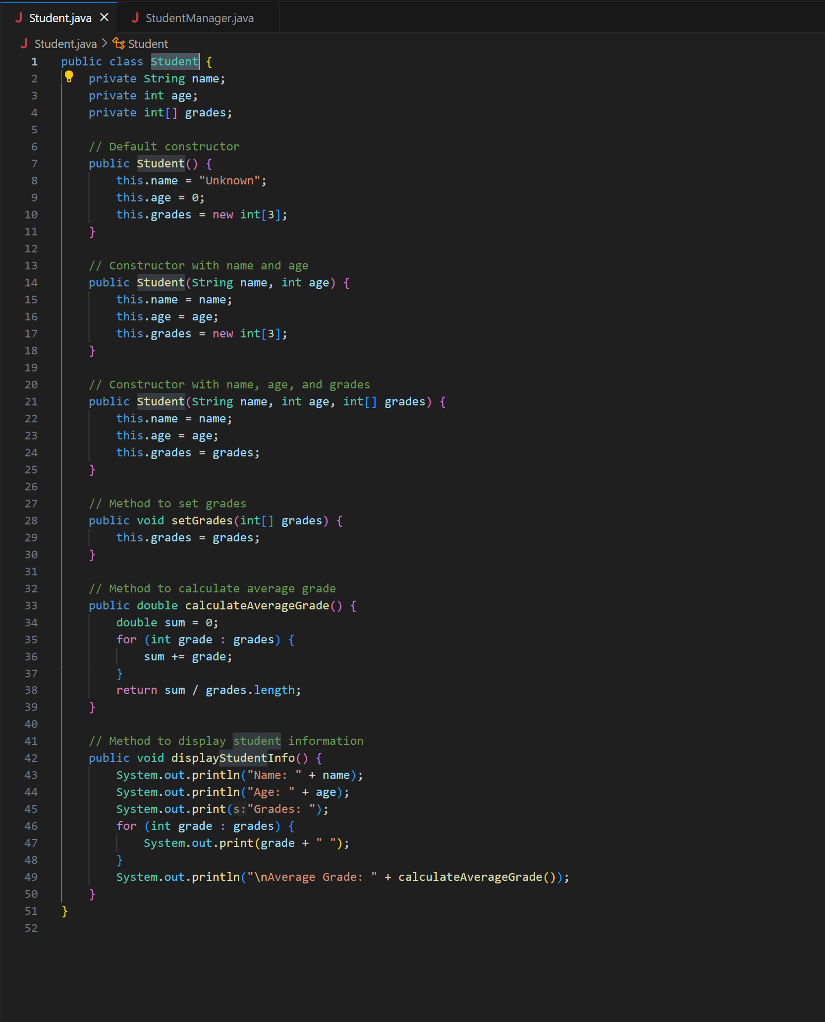

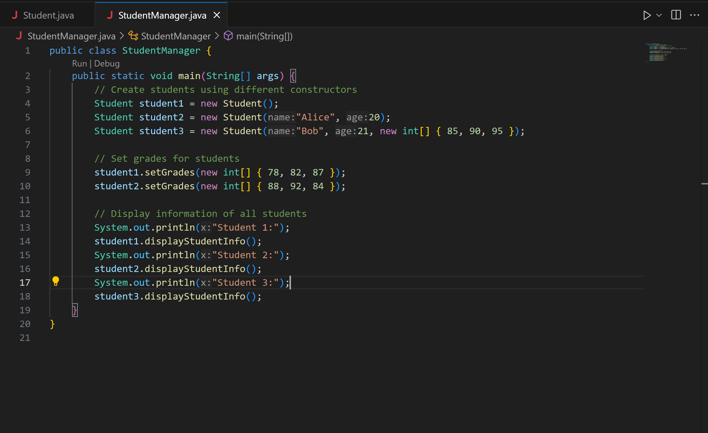

**Program Output/Results**

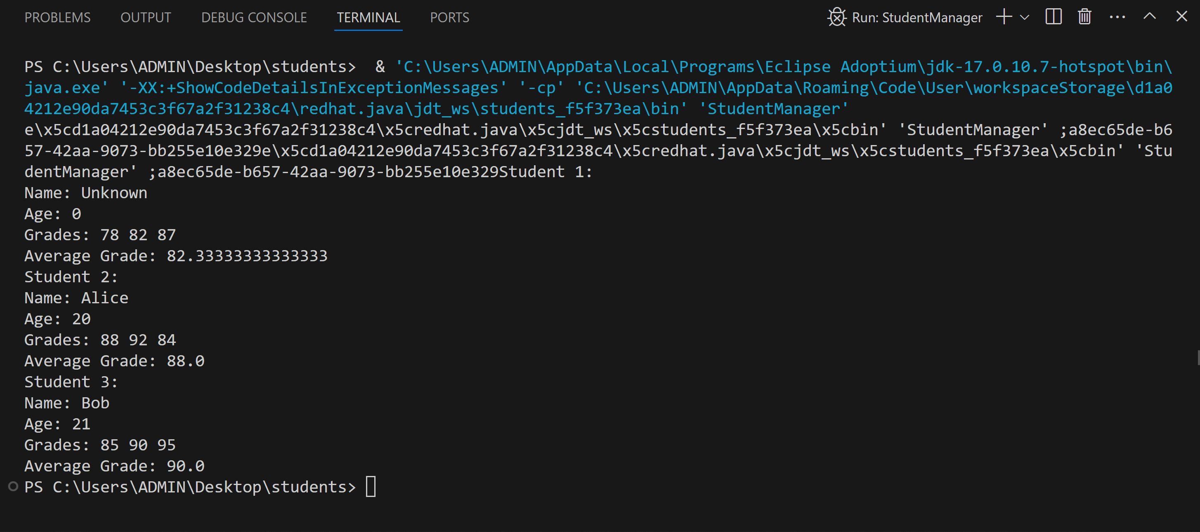

This program is well-designed to provide a grasp on the object-oriented programming basics in Java, building the necessary blocks that include class designing, method implementation, and overloading the constructor. It can be extended with functionalities like handling errors, data persistence, and a graphical user interface for a more professionalized student management system.