**Linear Regression Analysis**

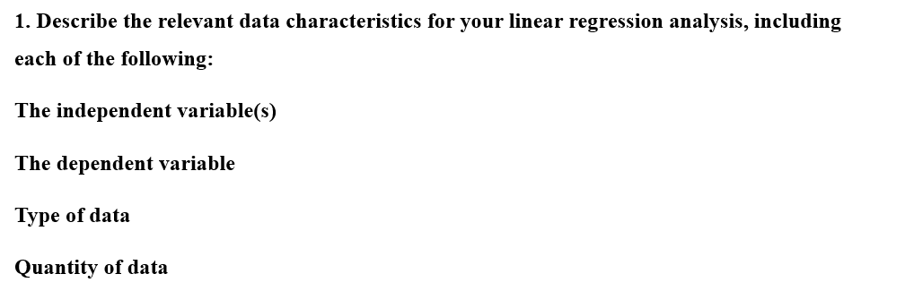

The independent variable is the Program Participation Rate, which indicates the percentage of nurses actively participating in the monthly employee well-being program. The dependent variable is the Nurse Attrition Rate (%), which represents the percentage of nurses leaving employment at the hospital over 36 months. The data is continuous and quantitative, as the independent and dependent variables are numerical and represent measurable quantities. There were 36 observations or data points for each variable.



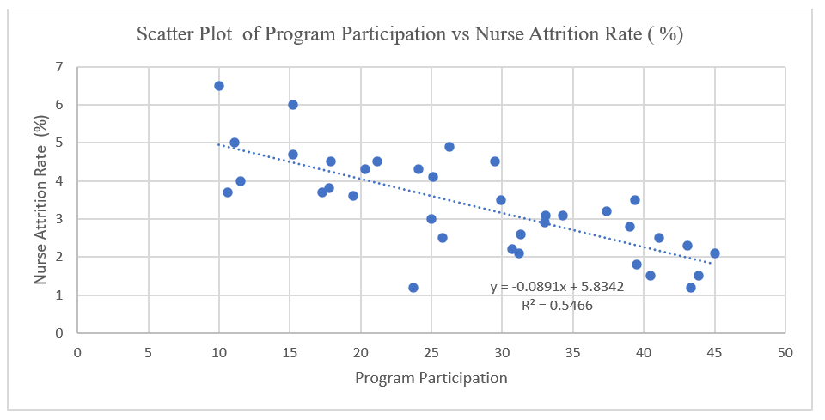

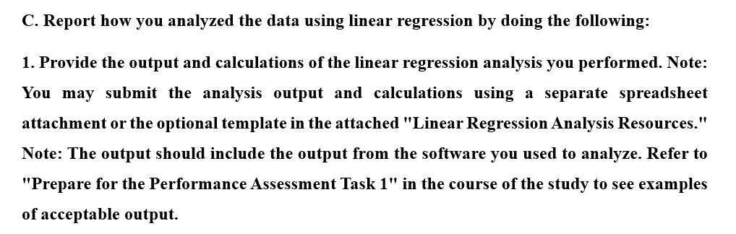

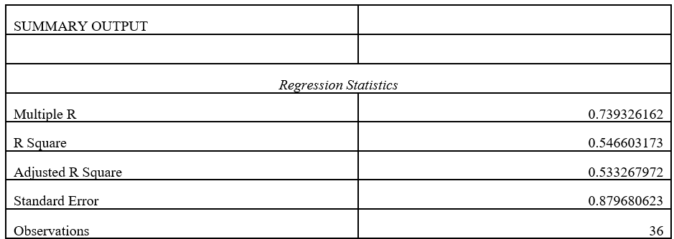

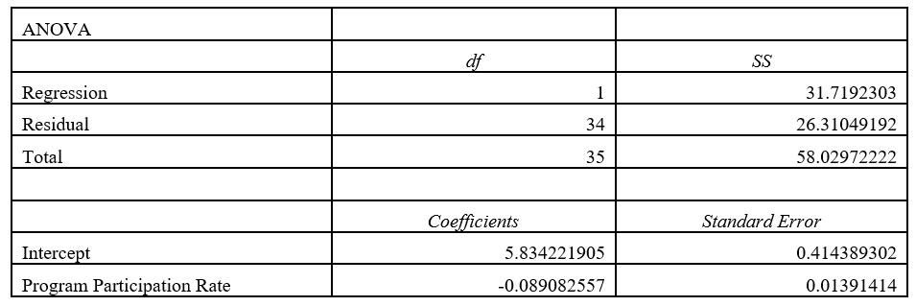

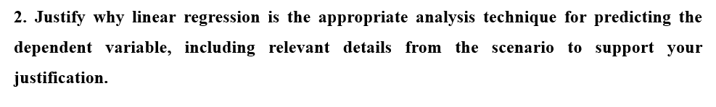

Linear regression was ideal here because it allows the prediction of a continuous dependent variable (nurse attrition rate) from an independent variable (Program Participation Rate). The data provided shows a linear trend, as the scatter plot indicates, and linear regression is a suitable method to quantify this relationship.

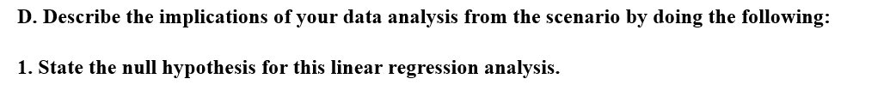

There is no association between program participation rate and nurse attrition rate.

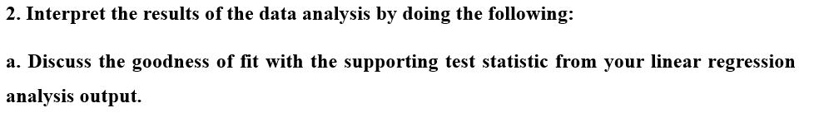

The goodness of fit is explained by R2 values = 0. 5466, implying that the program participation rate explains 54.66 % of the variation in nurse attrition.



As shown by the ANOVA table, the results are significant: F (1, 34) = 40.989 (3 d.p), p < .000. Therefore, we reject the null hypothesis and conclude that there exists an association between program participation rate and nurse attrition rate. Furthermore, the scatter plot shows a negative association between program participation and nurse attrition rate (as program participation decreases, nurse attrition rate increases).



Y = 5.834 (3 d.p) – 0.089X (3 d.p)

Y is the nurse attrition rate, and X is the program participation rate.

This equation enables one to predict the nurse attrition rate based on the Program Participation Rate.



One shortcoming of this research is the presence of confounding variables. The research focuses on only one variable (program participation rate) that could affect the nurse attrition rate. Other confounding variables affecting the nurse attrition rate include salary, workload, and external job opportunities. Failure to control the potential confounding variables may distort the relationship between program participation and nurse attrition rates.

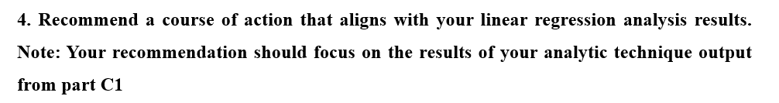

Based on the results indicating a negative association between Program Participation Rate and Nurse Attrition Rate, a suggested course of action could entail expanding the employee well-being program. Since the analysis shows that higher participation decreases the nurse attrition rate, the management should make an effort to encourage more nurses to participate in the program, which could include giving incentives to participants and raising awareness using targeted marketing strategies.