**Supply Chain Management Course for MBA Students**

Name

University

Course

Professor

Date

**Supply Chain Management Course for MBA Students**

The course's focus involves exploring how supply chain management (SCM) functions in the international market and digital marketplaces. The course will give learners the necessary skills to perform all relevant SCM functions for different sectors. The course focuses on fundamental SCM concepts such as integration, logistics, operations management, procurement, and information technologies through case studies, simulations, and class projects. The Supply Chain Management Essentials course is geared explicitly towards MBA learners, capturing the extensive SCM material in a 3-hour class. The learners will be introduced to the complex web of SCM, including procurement, operations management, and technology's dominant role in contemporary supply chains. With this all-inclusive strategy, students will fully master the practical tools of theoretical knowledge and go beyond theoretical concepts to use them tactically in practical applications.

**Learning Objectives**

The course has four main objectives. By the end of the course, the students will be able to point out and identify the components that make up the supply chain and their corresponding functions. They will develop a comprehension of the value of supply chain management in achieving organizational objectives. Students will also be competent at inspecting the multiple risks and possibilities underlying the world of supply chains. In addition, principles such as fundamental supply chain management precepts will enable them to deal efficiently with and solve simple problems encountered within the supply chain sphere.

**Coherent Narrative Presentation**

**Introduction (30 minutes):** The course introduction will cover what SCM is and identify its importance in allowing businesses to operate satisfactorily. Afterward, it will explore the SCM fundamentals, including planning, implementing, and monitoring from when the product is made to being with a consumer, highlighting its effects on value generation, cost reduction, and competitive advantage (Mukhamedjanova, 2020). Besides, the introduction will look at how SCM has evolved, stimulated by global events such as increased globalization, the rise of e-commerce, the push towards sustainability, and challenges posed by pandemics like COVID-19. The introduction will also focus on transitioning from the old to the newer, technology-based strategies, making the supply chains more adaptable and agile in the face of global market changes (Okeagu et al., 2021).

Real-world Examples: Most importantly, the course will use real-world examples to help students comprehend the application of strategic SCM principles. The first real-world example will be Unilever's Collaborative Planning, Forecasting, and Replenishment (CPFR) strategy, underlining how the business employs technology and supplier collaboration to streamline inventory and boost sales, illustrating the power of strategic partnerships in SCM (Salvi, 2020). Next, the course will examine Starbucks' vertically integrated supply chain, from sourcing coffee beans to serving the final product, to reiterate the benefits of supply chain integration and ethical sourcing in ensuring product quality and boosting brand image (Meilani & Ellitan, 2024). The last case study will be Walmart's utilization of vendor relationships and cross-docking techniques, demonstrating how these strategies reinforce the company's status as a retail sector leader by optimizing inventory management and facilitating efficient distribution.

**Challenges in Global Supply Chains (45 minutes):** Students will engage in a dynamic group activity around a real-world global supply chain problem case study analysis. It will entail dissecting complex situations impacted by geopolitical tensions, economic fluctuations, or social considerations, offering a deep dive into the complex web of global supply chain interdependences. The class will swing to how geopolitical events such as wars or sanctions, economic factors like currency value and inflation fluctuates, and social issues, such as consumer activism and labor practices, can affect supply chains. There will be a clear explanation of how diverse elements inter-relate, resulting in complications such as price instability, supply shortages, and consumer preferences. This section is custom-made to give students the skills to examine and find their way in the indefinite world of global supply chains, helping them in making knowledgeable decisions and creating effective strategies.

**Principles of Effective Supply Chain Management (60 minutes):**

**Interactive Lecture on Key SCM Principles: Agility, Sustainability, Resilience:** Emphasis will be on how supply chains quickly react to fluctuations; for instance, the changes in customer’s demands and problems they may face. There will be a talk about what to do in order to make supply chains more agile; more specifically, to make logistics more dynamic, to use flexible sourcing of materials, and to cut down on waste by using the approach of lean management (Sharma et al., 2021). The learner will also look at sustainability which involves taking care of the environment, being socially responsible, and being economically viable. Besides, there will be a discussion looki at the Triple bottom line approach that takes social, environmental, and financial aspects. At the end, it will focus on how supply chains can be ready for, address and recover from such incidents like natural hazards, supply shortages and substantial changes in the market.

**Breakout Sessions Where Students Apply These Principles to Develop Solutions for Case Study Problems:** Learners will be split into discussion groups to handle real-life supply chain challenges using sustainability, agility, and resilience principles. The groups will pinpoint problems in the case studies and develop solutions that apply these key SCM concepts, which will help learners see how these principles work in real situations and their impact on making supply chains more effective and reliable. Each group will share their solutions with the rest of the class, allowing everybody to learn from diverse viewpoints and strategies.

**Presentation Method.**

The learning method of our course has been purposefully selected to create a flexible and interactive learning experience. It will include Interactive Lectures that are not limited to introducing SCM core concepts but also enable student participation through questions and real-time polls, creating a truly interactive classroom. This kind of interactive lecture has not previously been presented in this course. This is enhanced by case studies and group discussions in which the learners can go into details of real-life situations, improving their analytical skills and bringing more practicality into theoretical concepts. Furthermore, the Breakout Sessions will be the central component of our learning philosophy, promoting teamwork exercises and perfecting interviewing capabilities. Therefore, this staggered mix of teaching strategies guarantees that every student can actively participate and use SCM in practice.

**Student Learning Assessment**

The student learning assessment is carefully developed to assess active involvement and knowledge application. Discussions constitute a critical element in the evaluation, where students are evaluated based on the quality and cooperation of their inputs during the group discussions and collaborative activities. It influences active contribution and improves their analytical skills in a team atmosphere. Adding to this is the case study analysis, an assignment where students analyze cases, diagnose weaknesses and provide sound solutions. This task aims to assess their ability to apply theoretical concepts to the real business problems encountered in the workplace, enhancing their knowledge of the topics studied. Below is the rubric that will be used:

Table 1: Assessment Rubric

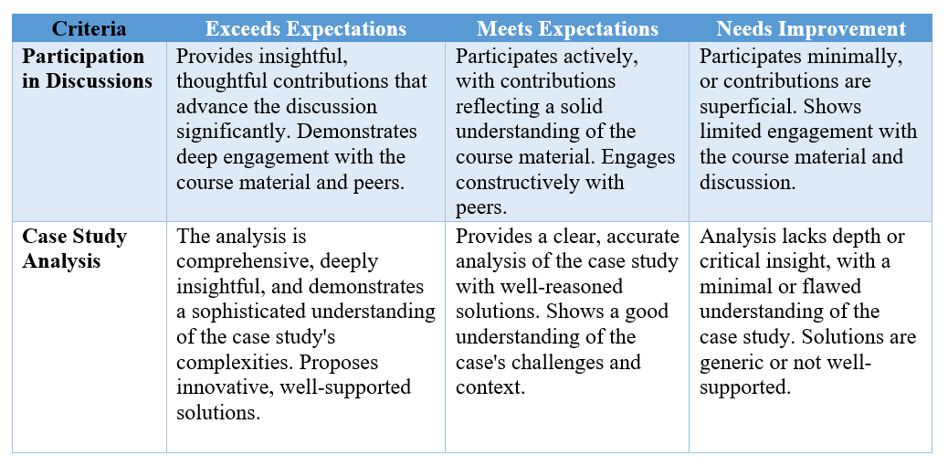

**Alignment of Assessment and Targeted Learning Objectives**

The assessment methods are closely linked with our primary learning outcomes to create a unified learning pathway. Contribution and discussion are directly associated with the second objective, which considers formulating organizational effectiveness through SCM. This interactive design element calls students to engage critically with the content and its implications. The Case study analysis is designed further to address objectives 1, 3, and 4 and for students to identify and understand the prime components of SCM, critically analyze the complex problems in a global context, and properly apply SCM principles to generate practical solutions. This alignment guarantees meaningful and in line with our educational goals.

**Conclusion**

This lesson plan for a session on supply chain management for MBA learners at the University of Sparkwimville is crafted to offer a solid foundation in SCM principles, engage the learners in critical thinking about global challenges, and apply learning to real-world situations. The assessment approaches are closely aligned with the learning objectives, ensuring learners can demonstrate their comprehension and application of the course material.

**References**

Asgari, N., Nikbakhsh, E., Hill, A., & Farahani, R. Z. (2016). Supply chain management 1982– 2015: A review. *IMA Journal of Management Mathematics*, *27*(3), 353-379. <https://doi.org/10.1093/imaman/dpw004>

Mavi, R. K., Goh, M., Mavi, N. K., Jie, F., Brown, K., Biermann, S., Khanfar, A. A. (2020). Cross-docking: A systematic literature review. *Sustainability*, *12*(11), 4789. <https://doi.org/10.3390/su12114789>

Meilani, T., & Ellitan, L. (2024). Supply chain management processes and competitive advantages: The case of Starbucks. *International Journal of Multidisciplinary Research and Publications (IJMRAP), 6*(8), 76-88. [https://www.researchgate.net/profile/Lena- Ellitan/publication/377574585_Supply_Chain_Management_Processes_and_Competitive _Advantage_The_Case_of_Starbucks/links/65add132f323f74ff1e44cd7/Supply-Chain- Management-Processes-and-Competitive-Advantage-The-Case-of-Starbucks.pdf](https://www.researchgate.net/profile/Lena-%09Ellitan/publication/377574585_Supply_Chain_Management_Processes_and_Competitive%09_Advantage_The_Case_of_Starbucks/links/65add132f323f74ff1e44cd7/Supply-Chain-%09Management-Processes-and-Competitive-Advantage-The-Case-of-Starbucks.pdf)

Mukhamedjanova, K. A. (2020). Concept of supply management. *Journal of Critical Reviews, 7*(2), 759-766. <https://jcreview.com/admin/Uploads/Files/61a742276f3234.26425361.pdf>

Okeagu, C. N., Reed, D. S., Sun, L., Colontonio, M. M., Rezayev, A., Ghaffar, Y. A., Kaye, R. J., Liu, H., Cornett, E. M., Fox, C. J., Urman, R. D., & Kaye, A. D. (2021). Principles of supply chain management in the time of crisis. *Best Practice & Research Clinical Anaesthesiology*, *35*(3), 369-376. <https://doi.org/10.1016/j.bpa.2020.11.007>

Salvi, V. Z. (2020). Supermarket global supply chain. *Archives of Business Research 8*(1), 192- 201. [https://www.researchgate.net/profile/Vinicius- Salvi/publication/339134292_The_Supermakets_Global_Chain/links/610d60aa169a1a01 03e2da38/The-Supermakets-Global-Chain.pdf](https://www.researchgate.net/profile/Vinicius-%09Salvi/publication/339134292_The_Supermakets_Global_Chain/links/610d60aa169a1a01%0903e2da38/The-Supermakets-Global-Chain.pdf)

Sharma, V., Raut, R. D., Mangla, S. K., Narkhede, B. E., Luthra, S., & Gokhale, R. (2021). A systematic literature review to integrate lean, agile, resilient, green and sustainable paradigms in the supply chain management. *Business Strategy and the Environment*, *30*(2), 1191-1212. <https://doi.org/10.1002/bse.2679>

Zhu, Z., Zhao, J., & Bush, A. A. (2020). The effects of e-business processes in supply chain operations: Process component and value creation mechanisms. *International Journal of Information Management*, *50*, 273-285. <https://doi.org/10.1016/j.ijinfomgt.2019.07.001>